Raspberry Pi RFID RC522 Chip

Reference:https://pimylifeup.com/raspberry-pi-rfid-rc522/

http://www.instructables.com/id/RFID-RC522-Raspberry-Pi/

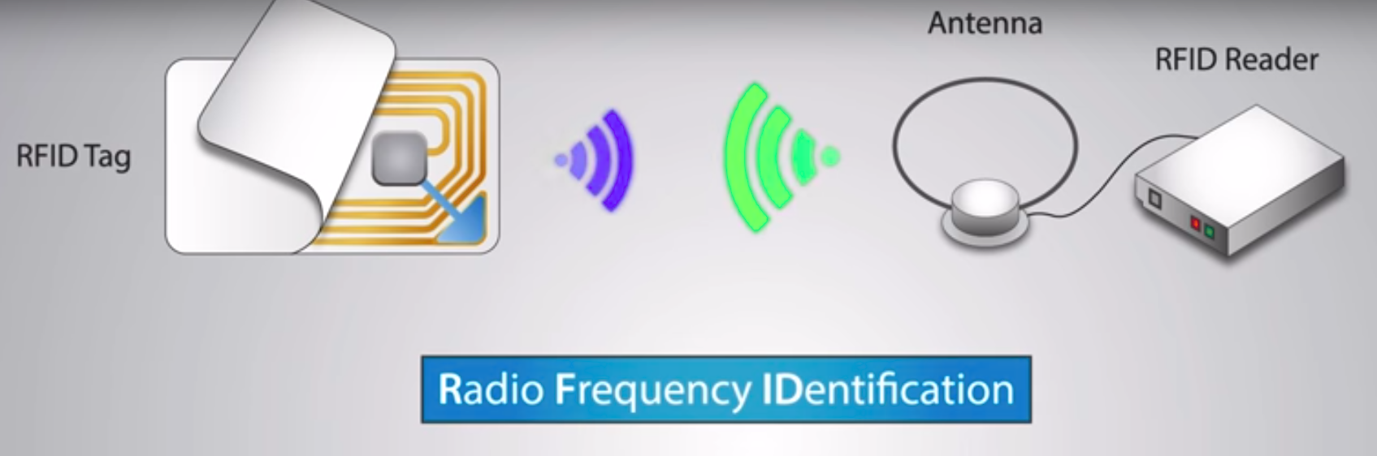

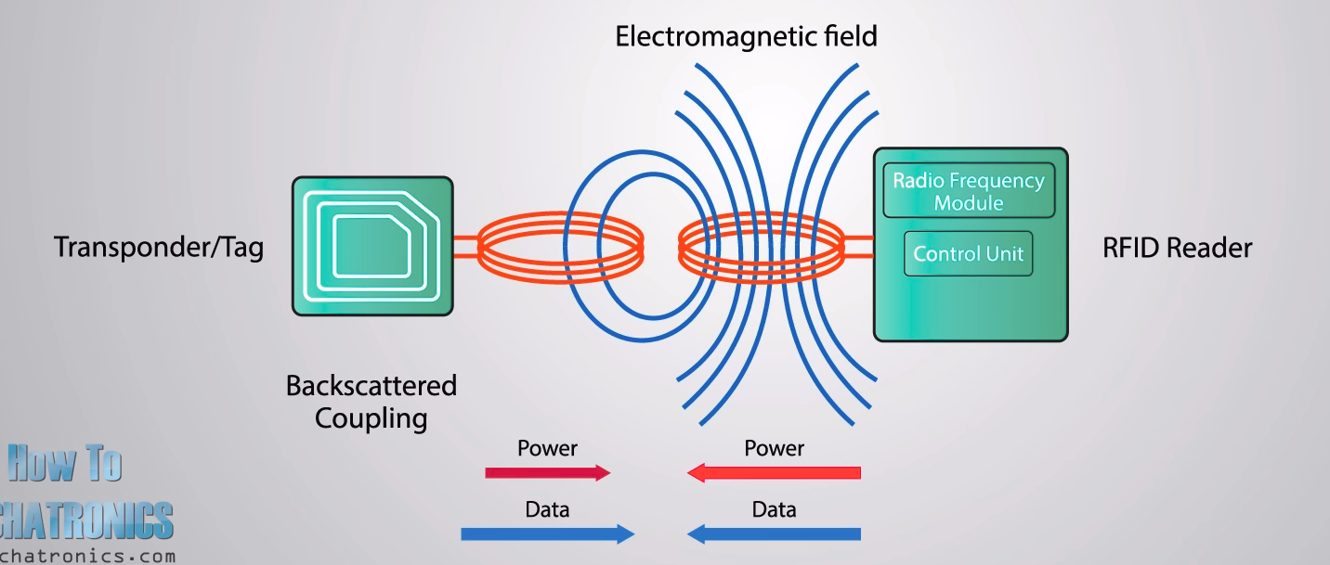

1.
SDA → 24
SCK → 23
MOSI → 19
MISO → 21
Leave IRQ
GND → 30
RST → 22
3.3V → 1

2. Remotely connect with pi

3. Set up Raspbian for the RFID RC522
We must first make changes to its configuration. By default, the Raspberry Pi has the SPI (Serial Peripheral Interface) disabled, which is a bit of a problem as that is what our RFID reader circuit runs through.
Follow the steps to configure your Raspberry Pi and Raspbian to utilize the SPI interface.
>> sudo raspi-config

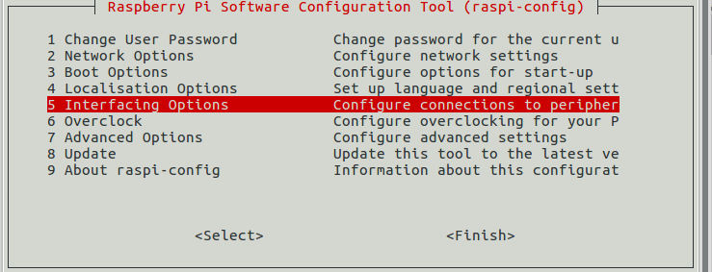
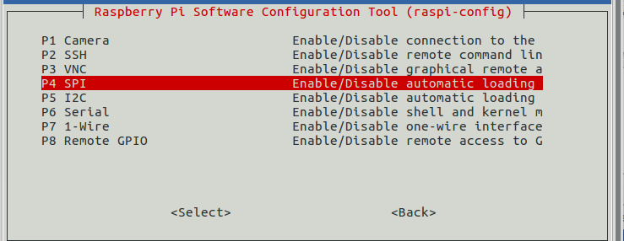

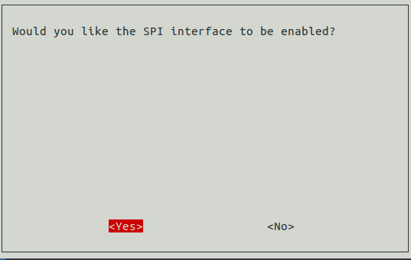

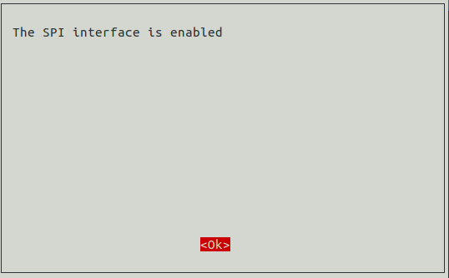

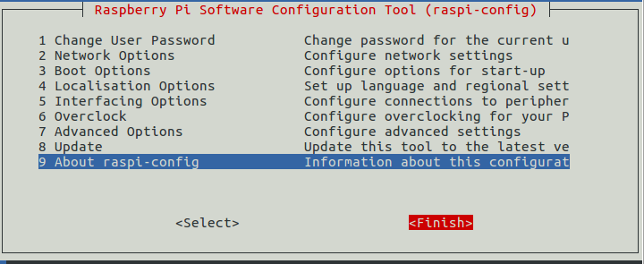

4. Reboot to make the changes in the pi
>> sudo reboot

5. Again Remotely connect to the pi

6. Make sure that it has in fact been enabled. The easiest way to Check by the following command to see if spi_bcm2835 is listed.
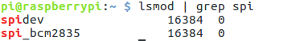

If you see spi_bcm2835 then you can proceed.

7. we first need to update our Raspberry Pi to ensure its running the latest version of all the software. Run the following two commands on your Raspberry Pi to update it.
>> sudo apt-get update
>> sudo apt-get upgrade

8. Install the package
>> sudo apt-get install python2.7-dev

9. To begin we must first clone the Python Library SPI Py and install it to our Raspberry Pi. This library helps handle interactions with the SPI and is a key component to this tutorial as we need it for the Raspberry Pi to interact with the RFID RC522.
>>cd ~
>> sudo apt-get install git

>> git clone https://github.com/lthiery/SPI-Py.git

10.With the SPI Py Python Library now cloned to our Raspberry Pi we need to install it, this is incredibly simple as all we need to do is change into its directory and run a simple python command on our Raspberry Pi.
>>
>> cd ~/SPI-Py
>> sudo python setup.py install

11. Now that we have installed SPI-Py we can now clone our RFID RC522 Python code from the PiMyLifeUp Github. There are two files included in this repository:
MFRC522.py which is an implementation of the RFID RC522 circuit.
SimpleMFRC522.py that takes the MFRC522.py file and greatly simplifies it.
To clone this repository, you can type the following two commands into your Raspberry Pi.
cd ~
git clone https://github.com/pimylifeup/MFRC522-python.git
12.Writing with the RFID RC522
For our first Python script, we will be showing you how to write data from the RC522 to your RFID tags. Thanks to the SimpleMFRC522 script this will be relatively simple, but we will still go into how each part of the code words.
1. 1. Begin by changing directory into our newly cloned folder, and begin writing our Write.py python script.
cd ~/MFRC522-python
sudo nano Write.py
2.Within this file, write the following lines of code. This will basically ask you for text to input and then write that text to the RFID Tag.
#!/usr/bin/env python

import RPi.GPIO as GPIO
import SimpleMFRC522
The first line of this segment of code helps tell the terminal how to interpret the file, it lets it know that it should use Python when executing it and not something else such as Bash.
Our first import, RPi.GPIO has all the functions needed to interact with the GPIO Pins, we need this to make sure they are cleared when the script finishes running.
The second import, imports in our SimpleMFRC522 library, this is what we will use to actually talk with the RFID RC522, it greatly simplifies dealing with the chip compared to the base MFRC522 library.
reader = SimpleMFRC522.SimpleMFRC522()
This line creates a copy of the SimpleMFRC522 as an object, runs its setup function then stores it all in our reader variable.
try:
text = raw_input('New data:')
print("Now place your tag to write")
reader.write(text)
print("Written")
Our next block of code we keep within a try statement, this is so we can catch any exceptions and clean up properly. Make sure that you retain the ‘tabs’ after try: as Python is whitespace sensitive, and it is how it differs between blocks of code.
The second line here reads in an input from the command line, we use raw_input in Python 2.7 to read in all input and store it in our text variable.
With the third line we utilize print() to notify the user that they can now place their RFID tag down onto the reader for writing.
Afterwards on our fourth line of code we use our reader object to write the values we stored in the text variable to the RFID tag, this will basically tell the RFID RC522 Circuit to write the text values to a certain sector.
Finally on the 5th line of code we use print() again to notify the user that we have successfully written to the RFID tag.
finally:
GPIO.cleanup()
Our final two lines of code basically handle exiting of the script. Finally, always occurs after the try statement, meaning no matter what we run the GPIO.cleanup() function. This is crucial as failing to cleanup can prevent other scripts from working correctly.
3. Once you have finished writing in your script, it should look something like below.
#!/usr/bin/env python

import RPi.GPIO as GPIO
import SimpleMFRC522

reader = SimpleMFRC522.SimpleMFRC522()

try:
text = raw_input('New data:')
print("Now place your tag to write")
reader.write(text)
print("Written")
finally:
GPIO.cleanup()
Once you are happy that the code looks correct you can save the file by pressing Ctrl + X then pressing Yand then finally hitting Enter.
4. Now that we have written our script, we will want to finally test it out. Before testing out the script make sure that you have a RFID tag handy. Once ready, type the following command into your Raspberry Pi’s terminal.
sudo python Write.py
5. You will be asked to write in the new data, in our case we are going to just type in pimylifeup as its short and simple. Press Enter when you are happy with what you have written.
6. With that done, simply place your RFID Tag on top of your RFID RC522 circuit. As soon as it detects it, it will immediately write the new data to the tag. You should see “Written” appear in your command line if it was successful.
You can look at our example output below to see what a successful run looks like.
pi@raspberrypi:~/MFRC522-python $ sudo python Write.py
New data:pimylifeup
Now place your tag to write
Written
7. You have now successfully written your Write.py script, we can now proceed to show you how to read data from the RFID RC522 in the next segment of this tutorial.

1. Let’s start off by changing directory to make sure we are in the right place, and then we can run nano to begin writing our Read.py script.
cd ~/MFRC522-python
sudo nano Read.py

3. Now that you have finished writing your Read.py script for your RFID RC522 it should look something like what is shown below:
#!/usr/bin/env python

import RPi.GPIO as GPIO
import SimpleMFRC522

reader = SimpleMFRC522.SimpleMFRC522()

try:
id, text = reader.read()
print(id)
print(text)
finally:
GPIO.cleanup()
4. Now that we have finally finished our Read.py script we need to test it out. Before we test out the script, grab one of your RFID tags that you want to read. Once that you are ready, type the following command into your Raspberry Pi’s terminal.
sudo python Read.py
5. With the script now running, all you need to do is place your RFID Tag on top of your RFID RC522 circuit. As soon as the Python script detects the RFID tag being placed on top it will immediately read the data and print it back out to you.
An example of what a successful output would look like is displayed below.
pi@raspberrypi:~/MFRC522-python $ sudo python Read.py
827843705425
pimylifeup

